# PROBLEM STATEMENT:

The motive of this project is to design a data base for a super market chain that has its branches in many cities it sells all the essentials, groceries etc. The data base maintains the record for the employees, suppliers, each store and the billing and payment details of the customers and the discounts offered to them based on the purchasing quantity.

# ER MODEL:

The following ER Diagram shows the way that the entities and the attributes being matched and represented with the constraints involved.

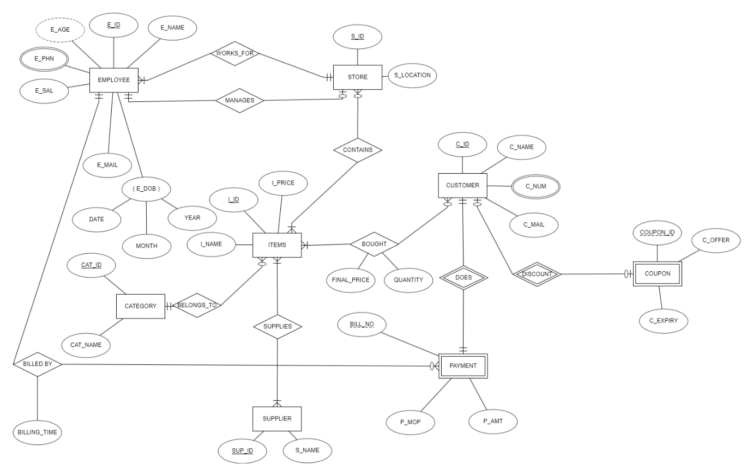

# RELATION SCHEMA:

The following Relational Schema shows the relational schema of the ER model of the Supermarket database. They are represented in tables with the attributes mentioned and indicating the primary foreign key for each relation in the schema.

# 

Now the schema is to be normalised.

# NORMALISATION:

The relations are:

Employee

* E_ID
* E_NAME
* E_SAL
* E_MAIL
* E_DOB
* S_ID

Functional dependencies are:

E_ID -> (E_NAME, E_SAL, E_MAIL, E_DOB, S_ID)

Relation is in BCNF implying it is also in 1NF,2NF,3NF.

Emp_phn

* E_ID
* E_PHN

There are no functional dependencies implying it’s in BCNF.

Store

* S_ID
* S_LOCATION
* M_ID

Functional dependencies are:

S_ID -> (S_location,M_ID)

Relation is in BCNF implying it is also in 1NF,2NF,3NF.

Customer

* C_ID
* C_NAME
* C_MAIL

Functional dependencies are:

C_ID -> (C_NAME,C_MAIL)

Relation is in BCNF implying it is also in 1NF,2NF,3NF.

C_PHN

* C_ID
* C_NUM

There are no functional dependencies implying it’s in BCNF.

CATEGORY

* CAT_ID
* CAT_NAME

Functional dependencies are:

CAT_ID -> (CAT_NAME)

Relation is in BCNF implying it is also in 1NF,2NF,3NF.

SUPPLIERS

* SUP_ID
* SUP_NAME

Functional dependencies are:

SUP_ID -> (SUP_NAME)

Relation is in BCNF implying it is also in 1NF,2NF,3NF.

ITEMS

* I_ID
* I_NAME
* I_PRICE
* CAT_ID

Functional dependencies are:

I_ID -> (I_NAME,I_PRICE,CAT_ID)

Relation is in BCNF implying it is also in 1NF,2NF,3NF.

SUPPLIES

* I_ID
* SUP_ID

There are no functional dependencies implying it’s in BCNF.

COUPON

* COUPON_NUM
* C_ID
* C_OFFER
* C_EXPIRY

Functional dependencies are:

C_ID,COUPON_NUM -> (C_OFFER,C_EXPIRY)

Relation is in BCNF implying it is also in 1NF,2NF,3NF.

Bought

* C_ID
* I_ID
* QUANTITY
* FINAL_PRICE

Functional dependencies are:

C_ID,I_ID -> (FINAL_PRICE,QUANTITY)

Relation is in BCNF implying it is also in 1NF,2NF,3NF.

CONTAINS

* S_ID
* I_id

There are no functional dependencies implying it’s in BCNF.

Payment

* Bill_No
* C_ID
* P_MOP
* P_AMT
* BILLING_TIME
* E_ID

Functional dependencies are:

C_ID,BILL_NO -> (P_MOP,P_AMT,BILLING_TIMR,E_ID)

Relation is in BCNF implying it is also in 1NF,2NF,3NF.

# RELATIONAL TABLE CREATION:

EMPLOYEE:

CREATE TABLE EMPLOYEE

(

E_ID INT PRIMARY KEY,

E_NAME VARCHAR(20),

E_SAL INT,

E_MAIL VARCHAR(20),

E_DOB DATE,

S_ID INT

);

# 

EMP_PHN

CREATE TABLE EMP_PHN

(

E_PHN INT,

E_ID INT,

PRIMARY KEY(E_PHN,E_ID),

FOREIGN KEY (E_ID) REFERENCES EMPLOYEE(E_ID)

);

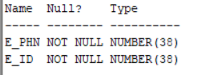

STORE:

CREATE TABLE "STORE"

(

S_ID INT PRIMARY KEY,

S_LOCATION VARCHAR(20),

M_ID INT,

FOREIGN KEY (M_ID) REFERENCES EMPLOYEE(E_ID)

);

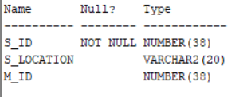

ALTER TABLE EMPLOYEE

ADD FOREIGN KEY (S_ID) REFERENCES "STORE"(S_ID);

CATEGORY:

CREATE TABLE CATEGORY

(

CAT_ID INT PRIMARY KEY,

CAT_NAME VARCHAR(20)

);

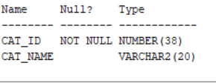

SUPPLIERS:

CREATE TABLE SUPPLIERS

(

SUP_ID INT PRIMARY KEY,

SUP_NAME VARCHAR(20)

);

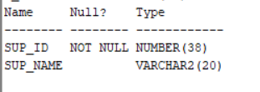

ITEMS:

CREATE TABLE ITEMS

(

I_ID INT PRIMARY KEY,

I_NAME VARCHAR(20),

I_PRICE INT,

CAT_ID INT,

FOREIGN KEY (CAT_ID) REFERENCES CATEGORY(CAT_ID)

);

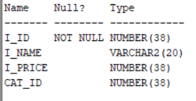

SUPPLIES:

CREATE TABLE SUPPLIES

(

SUP_ID INT ,

I_ID INT,

PRIMARY KEY(SUP_ID,I_ID),

FOREIGN KEY(SUP_ID) REFERENCES SUPPLIERS(SUP_ID),

FOREIGN KEY(I_ID) REFERENCES ITEMS(I_ID)

);

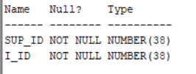

CONTAINS:

CREATE TABLE CONTAINS

(

S_ID INT ,

I_ID INT,

PRIMARY KEY(S_ID,I_ID),

FOREIGN KEY(S_ID) REFERENCES "STORE"(S_ID),

FOREIGN KEY(I_ID) REFERENCES ITEMS(I_ID)

);

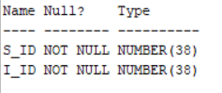

CUSTOMER:

CREATE TABLE CUSTOMER

(

C_ID INT PRIMARY KEY,

C_NAME VARCHAR(20),

C_MAIL VARCHAR(20)

);

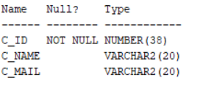

C_PHN:

CREATE TABLE C_PHN

(

C_ID INT ,

C_NUM INT,

PRIMARY KEY(C_ID,C_NUM),

FOREIGN KEY (C_ID) REFERENCES CUSTOMER(C_ID)

);

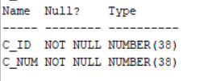

COUPON:

CREATE TABLE COUPON

(

COUPON_NUM INT,

C_ID INT,

C_OFFER INT,

C_EXPIRY DATE,

PRIMARY KEY(COUPON_NUM,C_ID),

FOREIGN KEY (C_ID) REFERENCES CUSTOMER(C_ID)

);

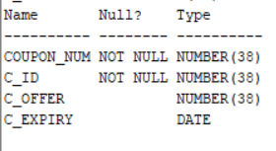

BOUGHT:

CREATE TABLE BOUGHT

(

C_ID INT,

I_ID INT,

FINAL_PRICE INT,

QUANTITY INT,

PRIMARY KEY(C_ID,I_ID),

FOREIGN KEY (C_ID) REFERENCES CUSTOMER(C_ID),

FOREIGN KEY (I_ID) REFERENCES ITEMS(I_ID)

);

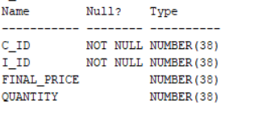

PAYMENT:

CREATE TABLE PAYMENT

(

BILL_NO INT,

C_ID INT,

P_MOP VARCHAR(20),

P_AMT INT,

BILLING_TIME TIMESTAMP,

E_ID INT,

PRIMARY KEY(BILL_NO,C_ID),

FOREIGN KEY(C_ID) REFERENCES CUSTOMER(C_ID),

FOREIGN KEY(E_ID) REFERENCES EMPLOYEE(E_ID)

);

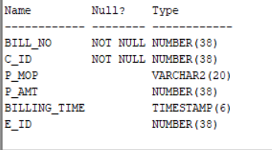

# INSERTION OF VALUES INTO THE RELATIONS:

INSERT INTO employee (E_ID, E_NAME, E_SAL, E_MAIL, E_DOB, S_ID) VALUES (1, 'John', 50000, 'john@email.com', '01-01-1990', NULL);

INSERT INTO employee (E_ID, E_NAME, E_SAL, E_MAIL, E_DOB, S_ID) VALUES (2, 'Sarah', 55000, 'sarah@email.com', '02-02-1991', NULL);

INSERT INTO employee (E_ID, E_NAME, E_SAL, E_MAIL, E_DOB, S_ID) VALUES (3, 'Mike', 60000, 'mike@email.com', '03-03-1992', NULL);

INSERT INTO employee (E_ID, E_NAME, E_SAL, E_MAIL, E_DOB, S_ID) VALUES (4, 'Emily', 65000, 'emily@email.com', '04-04-1993', NULL);

INSERT INTO employee (E_ID, E_NAME, E_SAL, E_MAIL, E_DOB, S_ID) VALUES (5, 'David', 70000, 'david@email.com', '05-05-1994', NULL);

INSERT INTO employee (E_ID, E_NAME, E_SAL, E_MAIL, E_DOB, S_ID) VALUES (6, 'Jessica', 75000, 'jessica@email.com', '06-06-1995', NULL);

INSERT INTO employee (E_ID, E_NAME, E_SAL, E_MAIL, E_DOB, S_ID) VALUES (7, 'Mark', 80000, 'mark@email.com', '07-07-1996', NULL);

INSERT INTO employee (E_ID, E_NAME, E_SAL, E_MAIL, E_DOB, S_ID) VALUES (8, 'Linda', 85000, 'linda@email.com', '08-08-1997', NULL);

INSERT INTO employee (E_ID, E_NAME, E_SAL, E_MAIL, E_DOB, S_ID) VALUES (9, 'Brian', 90000, 'brian@email.com', '09-09-1997', NULL);

INSERT INTO employee (E_ID, E_NAME, E_SAL, E_MAIL, E_DOB, S_ID) VALUES (10, 'Emma', 95000, 'emma@email.com', '10-10-1999', NULL);

INSERT INTO employee (E_ID, E_NAME, E_SAL, E_MAIL, E_DOB, S_ID) VALUES (11, 'Kevin', 100000, 'kevin@email.com', '11-11-2000', NULL);

INSERT INTO employee (E_ID, E_NAME, E_SAL, E_MAIL, E_DOB, S_ID) VALUES (12, 'Olivia', 105000, 'olivia@email.com', '12-12-2001', NULL);

INSERT INTO employee (E_ID, E_NAME, E_SAL, E_MAIL, E_DOB, S_ID) VALUES (13, 'Jacob', 110000, 'jacob@email.com', '01-01-2002', NULL);

INSERT INTO employee (E_ID, E_NAME, E_SAL, E_MAIL, E_DOB, S_ID) VALUES (14, 'Avery', 115000, 'avery@email.com', '02-02-2003', NULL);

DELETE FROM EMPLOYEE;

SELECT * FROM EMPLOYEE;

INSERT INTO store (S_ID, S_LOCATION, M_ID) VALUES (1, 'New York', 1);

INSERT INTO store (S_ID, S_LOCATION, M_ID) VALUES (2, 'Los Angeles', 2);

INSERT INTO store (S_ID, S_LOCATION, M_ID) VALUES (3, 'Chicago', 3);

SELECT * FROM STORE;

UPDATE EMPLOYEE SET S_ID=1 WHERE E_ID IN (1,4,7);

UPDATE EMPLOYEE SET S_ID=2 WHERE E_ID IN (2,5,8);

UPDATE EMPLOYEE SET S_ID=3 WHERE E_ID IN (3,6,9,10);

INSERT INTO emp_phn (E_ID, E_PHN) VALUES (1, '123-456-7890');

INSERT INTO emp_phn (E_ID, E_PHN) VALUES (1, '987-654-3210');

INSERT INTO emp_phn (E_ID, E_PHN) VALUES (2, '555-555-5555');

INSERT INTO emp_phn (E_ID, E_PHN) VALUES (2, '111-111-1111');

INSERT INTO emp_phn (E_ID, E_PHN) VALUES (2, '222-222-2222');

INSERT INTO emp_phn (E_ID, E_PHN) VALUES (3, '333-333-3333');

INSERT INTO emp_phn (E_ID, E_PHN) VALUES (3, '444-444-4444');

INSERT INTO emp_phn (E_ID, E_PHN) VALUES (4, '555-555-5555');

INSERT INTO emp_phn (E_ID, E_PHN) VALUES (5, '666-666-6666');

INSERT INTO emp_phn (E_ID, E_PHN) VALUES (5, '777-777-7777');

INSERT INTO emp_phn (E_ID, E_PHN) VALUES (6, '888-888-8888');

INSERT INTO emp_phn (E_ID, E_PHN) VALUES (7, '999-999-9999');

INSERT INTO emp_phn (E_ID, E_PHN) VALUES (7, '111-222-3333');

INSERT INTO emp_phn (E_ID, E_PHN) VALUES (7, '444-555-6666');

INSERT INTO emp_phn (E_ID, E_PHN) VALUES (8, '777-777-7777');

INSERT INTO emp_phn (E_ID, E_PHN) VALUES (8, '888-888-8888');

INSERT INTO emp_phn (E_ID, E_PHN) VALUES (8, '999-999-9999');

INSERT INTO emp_phn (E_ID, E_PHN) VALUES (9, '111-111-1111');

INSERT INTO emp_phn (E_ID, E_PHN) VALUES (9, '222-222-2222');

INSERT INTO emp_phn (E_ID, E_PHN) VALUES (10, '333-333-3333');

SELECT * FROM EMP_PHN;

INSERT INTO suppliers (sup_id, sup_name) VALUES (1, 'Supplier A');

INSERT INTO suppliers (sup_id, sup_name) VALUES (2, 'Supplier B');

INSERT INTO suppliers (sup_id, sup_name) VALUES (3, 'Supplier C');

INSERT INTO suppliers (sup_id, sup_name) VALUES (4, 'Supplier D');

INSERT INTO suppliers (sup_id, sup_name) VALUES (5, 'Supplier E');

INSERT INTO suppliers (sup_id, sup_name) VALUES (6, 'Supplier F');

SELECT * FROM SUPPLIERS;

INSERT INTO category (cat_id, cat_name) VALUES (1, 'Category A');

INSERT INTO category (cat_id, cat_name) VALUES (2, 'Category B');

INSERT INTO category (cat_id, cat_name) VALUES (3, 'Category C');

INSERT INTO category (cat_id, cat_name) VALUES (4, 'Category D');

INSERT INTO category (cat_id, cat_name) VALUES (5, 'Category E');

SELECT * FROM CATEGORY;

INSERT INTO items (i_id, i_name, i_price, cat_id) VALUES (1, 'Item A', 10, 1);

INSERT INTO items (i_id, i_name, i_price, cat_id) VALUES (2, 'Item B', 20, 2);

INSERT INTO items (i_id, i_name, i_price, cat_id) VALUES (3, 'Item C', 5, 3);

INSERT INTO items (i_id, i_name, i_price, cat_id) VALUES (4, 'Item D', 15, 4);

INSERT INTO items (i_id, i_name, i_price, cat_id) VALUES (5, 'Item E', 8, 5);

INSERT INTO items (i_id, i_name, i_price, cat_id) VALUES (6, 'Item F', 12, 1);

INSERT INTO items (i_id, i_name, i_price, cat_id) VALUES (7, 'Item G', 7, 2);

INSERT INTO items (i_id, i_name, i_price, cat_id) VALUES (8, 'Item H', 25, 3);

INSERT INTO items (i_id, i_name, i_price, cat_id) VALUES (9, 'Item I', 18, 4);

INSERT INTO items (i_id, i_name, i_price, cat_id) VALUES (10, 'Item J', 14, 5);

INSERT INTO items (i_id, i_name, i_price, cat_id) VALUES (11, 'Item K', 22, 1);

INSERT INTO items (i_id, i_name, i_price, cat_id) VALUES (12, 'Item L', 30, 2);

INSERT INTO items (i_id, i_name, i_price, cat_id) VALUES (13, 'Item M', 16, 3);

INSERT INTO items (i_id, i_name, i_price, cat_id) VALUES (14, 'Item N', 11, 4);

INSERT INTO items (i_id, i_name, i_price, cat_id) VALUES (15, 'Item O', 20, 5);

INSERT INTO items (i_id, i_name, i_price, cat_id) VALUES (16, 'Item P', 15, 1);

INSERT INTO items (i_id, i_name, i_price, cat_id) VALUES (17, 'Item Q', 12, 2);

INSERT INTO items (i_id, i_name, i_price, cat_id) VALUES (18, 'Item R', 28, 3);

INSERT INTO items (i_id, i_name, i_price, cat_id) VALUES (19, 'Item S', 32, 4);

INSERT INTO items (i_id, i_name, i_price, cat_id) VALUES (20, 'Item T', 19, 5);

SELECT * FROM ITEMS;

INSERT INTO supplies (i_id, sup_id) VALUES (1, 1);

INSERT INTO supplies (i_id, sup_id) VALUES (1, 3);

INSERT INTO supplies (i_id, sup_id) VALUES (2, 2);

INSERT INTO supplies (i_id, sup_id) VALUES (2, 3);

INSERT INTO supplies (i_id, sup_id) VALUES (3, 5);

INSERT INTO supplies (i_id, sup_id) VALUES (3, 6);

INSERT INTO supplies (i_id, sup_id) VALUES (4, 4);

INSERT INTO supplies (i_id, sup_id) VALUES (4, 2);

INSERT INTO supplies (i_id, sup_id) VALUES (5, 1);

INSERT INTO supplies (i_id, sup_id) VALUES (5, 4);

INSERT INTO supplies (i_id, sup_id) VALUES (6, 1);

INSERT INTO supplies (i_id, sup_id) VALUES (6, 2);

INSERT INTO supplies (i_id, sup_id) VALUES (7, 6);

INSERT INTO supplies (i_id, sup_id) VALUES (7, 3);

INSERT INTO supplies (i_id, sup_id) VALUES (8, 5);

INSERT INTO supplies (i_id, sup_id) VALUES (8, 6);

INSERT INTO supplies (i_id, sup_id) VALUES (9, 4);

INSERT INTO supplies (i_id, sup_id) VALUES (9, 2);

INSERT INTO supplies (i_id, sup_id) VALUES (10, 1);

INSERT INTO supplies (i_id, sup_id) VALUES (10, 6);

INSERT INTO supplies (i_id, sup_id) VALUES (11, 1);

INSERT INTO supplies (i_id, sup_id) VALUES (12, 4);

INSERT INTO supplies (i_id, sup_id) VALUES (13, 1);

INSERT INTO supplies (i_id, sup_id) VALUES (14, 2);

INSERT INTO supplies (i_id, sup_id) VALUES (14, 6);

INSERT INTO supplies (i_id, sup_id) VALUES (15, 3);

INSERT INTO supplies (i_id, sup_id) VALUES (15, 5);

INSERT INTO supplies (i_id, sup_id) VALUES (16, 6);

INSERT INTO supplies (i_id, sup_id) VALUES (16, 4);

INSERT INTO supplies (i_id, sup_id) VALUES (17, 2);

INSERT INTO supplies (i_id, sup_id) VALUES (17, 1);

INSERT INTO supplies (i_id, sup_id) VALUES (18, 6);

INSERT INTO supplies (i_id, sup_id) VALUES (19, 2);

INSERT INTO supplies (i_id, sup_id) VALUES (20, 1);

INSERT INTO supplies (i_id, sup_id) VALUES (20, 6);

SELECT * FROM SUPPLIES;

INSERT INTO customer (c_id, c_name, c_mail) VALUES (1, 'John Smith', 'john@gmail.com');

INSERT INTO customer (c_id, c_name, c_mail) VALUES (2, 'Emily Brown', 'brown@gmail.com');

INSERT INTO customer (c_id, c_name, c_mail) VALUES (3, 'Jacob Lee', 'lee@gmail.com');

INSERT INTO customer (c_id, c_name, c_mail) VALUES (4, 'Sophie Davis', 'sop.gmail.com');

INSERT INTO customer (c_id, c_name, c_mail) VALUES (5, 'William Johnson', 'johnson@gmail.com');

INSERT INTO customer (c_id, c_name, c_mail) VALUES (6, 'Olivia Taylor', 'taylor@gmail.com');

INSERT INTO customer (c_id, c_name, c_mail) VALUES (7, 'Ethan Wilson', 'wilson@gmail.com');

select * from customer;

INSERT INTO coupon VALUES (1, 1,5, '31-12-2023');

INSERT INTO coupon VALUES (2, 2,6, '15-06-2024');

INSERT INTO coupon VALUES (3, 3,7, '30-09-2023');

INSERT INTO coupon VALUES (4, 4,8, '31-12-2024');

INSERT INTO coupon VALUES (5, 5,9, '31-03-2025');

INSERT INTO coupon VALUES (6, 6,10, '31-12-2023');

INSERT INTO coupon VALUES (7, 7,11, '30-06-2024');

select * from coupon;

delete from coupon;

INSERT INTO C_PHN (c_id, c_num) VALUES (1, '1234567890');

INSERT INTO C_PHN (c_id, c_num) VALUES (1, '9876543210');

INSERT INTO C_PHN (c_id, c_num) VALUES (2, '5555555555');

INSERT INTO C_PHN (c_id, c_num) VALUES (3, '1111111111');

INSERT INTO C_PHN (c_id, c_num) VALUES (4, '9999999999');

INSERT INTO C_PHN (c_id, c_num) VALUES (5, '7777777777');

INSERT INTO C_PHN (c_id, c_num) VALUES (6, '8888888888');

INSERT INTO C_PHN (c_id, c_num) VALUES (7, '5553331234');

INSERT INTO C_PHN (c_id, c_num) VALUES (5, '5554444321');

INSERT INTO C_PHN (c_id, c_num) VALUES (2, '5556665678');

SELECT * FROM C_PHN;

INSERT INTO contains (s_id, i_id) VALUES (1, 1);

INSERT INTO contains (s_id, i_id) VALUES (2, 5);

INSERT INTO contains (s_id, i_id) VALUES (3, 10);

INSERT INTO contains (s_id, i_id) VALUES (4, 15);

INSERT INTO contains (s_id, i_id) VALUES (5, 19);

INSERT INTO contains (s_id, i_id) VALUES (1, 3);

INSERT INTO contains (s_id, i_id) VALUES (2, 6);

INSERT INTO contains (s_id, i_id) VALUES (3, 12);

INSERT INTO contains (s_id, i_id) VALUES (4, 18);

INSERT INTO contains (s_id, i_id) VALUES (5, 13);

INSERT INTO contains (s_id, i_id) VALUES (1, 7);

INSERT INTO contains (s_id, i_id) VALUES (2, 9);

INSERT INTO contains (s_id, i_id) VALUES (3, 16);

INSERT INTO contains (s_id, i_id) VALUES (4, 4);

INSERT INTO contains (s_id, i_id) VALUES (5, 8);

INSERT INTO contains (s_id, i_id) VALUES (1, 11);

INSERT INTO contains (s_id, i_id) VALUES (2, 14);

INSERT INTO contains (s_id, i_id) VALUES (3, 2);

INSERT INTO contains (s_id, i_id) VALUES (4, 17);

INSERT INTO contains (s_id, i_id) VALUES (5, 1);

INSERT INTO contains (s_id, i_id) VALUES (1, 1);

INSERT INTO contains (s_id, i_id) VALUES (1, 2);

INSERT INTO contains (s_id, i_id) VALUES (1, 3);

INSERT INTO contains (s_id, i_id) VALUES (1, 4);

INSERT INTO contains (s_id, i_id) VALUES (1, 5);

INSERT INTO contains (s_id, i_id) VALUES (1, 6);

INSERT INTO contains (s_id, i_id) VALUES (1, 7);

INSERT INTO contains (s_id, i_id) VALUES (2, 8);

INSERT INTO contains (s_id, i_id) VALUES (2, 9);

INSERT INTO contains (s_id, i_id) VALUES (2, 10);

INSERT INTO contains (s_id, i_id) VALUES (2, 11);

INSERT INTO contains (s_id, i_id) VALUES (2, 12);

INSERT INTO contains (s_id, i_id) VALUES (2, 13);

INSERT INTO contains (s_id, i_id) VALUES (2, 14);

INSERT INTO contains (s_id, i_id) VALUES (3, 15);

INSERT INTO contains (s_id, i_id) VALUES (3, 16);

INSERT INTO contains (s_id, i_id) VALUES (3, 17);

INSERT INTO contains (s_id, i_id) VALUES (3, 18);

INSERT INTO contains (s_id, i_id) VALUES (3, 19);

INSERT INTO contains (s_id, i_id) VALUES (3, 20);

SELECT * FROM CONTAINS;

CREATE TRIGGER COST_CAL

BEFORE INSERT

ON BOUGHT

FOR EACH ROW

DECLARE

IND_PRICE INT;

BEGIN

SELECT ITEMS.I_PRICE INTO IND_PRICE FROM ITEMS WHERE ITEMS.I_ID=:NEW.I_ID;

:NEW.FINAL_PRICE:=:NEW.QUANTITY*IND_PRICE;

END;

/

DELETE FROM BOUGHT;

INSERT INTO BOUGHT VALUES(1,1,20,2);

INSERT INTO BOUGHT VALUES(1,10,14,1);

INSERT INTO BOUGHT VALUES(1,20,57,3);

INSERT INTO BOUGHT VALUES(2,2,40,2);

INSERT INTO BOUGHT VALUES(2,11,22,1);

INSERT INTO BOUGHT VALUES(2,12,90,3);

INSERT INTO BOUGHT VALUES(3,3,10,2);

INSERT INTO BOUGHT VALUES(3,13,16,1);

INSERT INTO BOUGHT VALUES(3,7,21,3);

INSERT INTO BOUGHT VALUES(4,4,75,5);

INSERT INTO BOUGHT VALUES(4,5,16,2);

INSERT INTO BOUGHT VALUES(5,16,60,4);

INSERT INTO BOUGHT VALUES(6,15,50,2);

INSERT INTO BOUGHT VALUES(7,9,18,1);

SELECT * FROM BOUGHT;

--SELECT BOUGHT.C_ID,SUM(BOUGHT.FINAL_PRICE) FROM BOUGHT GROUP BY BOUGHT.C_ID ORDER BY C_ID ASC;

CREATE TRIGGER PAMT

BEFORE INSERT

ON PAYMENT

FOR EACH ROW

DECLARE

DISCOUNT INT;

B_DISCOUNT INT;

BEGIN

SELECT COUPON.C_OFFER INTO DISCOUNT FROM COUPON WHERE :NEW.C_ID=COUPON.C_ID;

SELECT ABC INTO B_DISCOUNT FROM

(SELECT BOUGHT.C_ID as dup_id,SUM(BOUGHT.FINAL_PRICE) AS ABC

FROM BOUGHT

GROUP BY BOUGHT.C_ID ORDER BY C_ID ASC)DT

WHERE :NEW.C_ID=DT.dup_id;

:NEW.P_AMT:=B_DISCOUNT-DISCOUNT;

END;

/

insert into payment values (1,1,'cash',86,TO_TIMESTAMP( '03-11-2001 03:22:10'),1);

insert into payment values (2,2,'card',146,TO_TIMESTAMP( '04-12-2001 04:20:11'),2);

insert into payment values (3,3,'cash',40,TO_TIMESTAMP( '05-01-2004 06:22:33'),3);

insert into payment values (4,4,'cash',73,TO_TIMESTAMP( '06-11-2006 03:18:10'),4);

insert into payment values (5,5,'cash',51,TO_TIMESTAMP( '05-04-2001 06:29:10'),5);

insert into payment values (6,6,'cash',40,TO_TIMESTAMP( '03-11-2001 03:22:10'),6);

insert into payment values (7,7,'cash',7,TO_TIMESTAMP( '03-06-2001 03:11:10'),7);

select * from payment;

delete from payment;S